Name: ____________________ Period: ____ Date: ________

Sunny Meadows Predictions
Initial Explanations and Prediction
Organisms eat one another to obtain organic matter and chemical energy. In order for a population of organisms to survive there must be enough food (organic matter) for the population to eat. So all the fox in an ecosystem depend on having enough food—like rabbits—to eat.
Prediction #1: In this investigation you will try to create a large fox population by adjusting the number of plants, rabbits, and foxes in the ecosystem. Keep in mind that rabbits eat the plants, and the fox eat the rabbits, so all three organisms are connected.
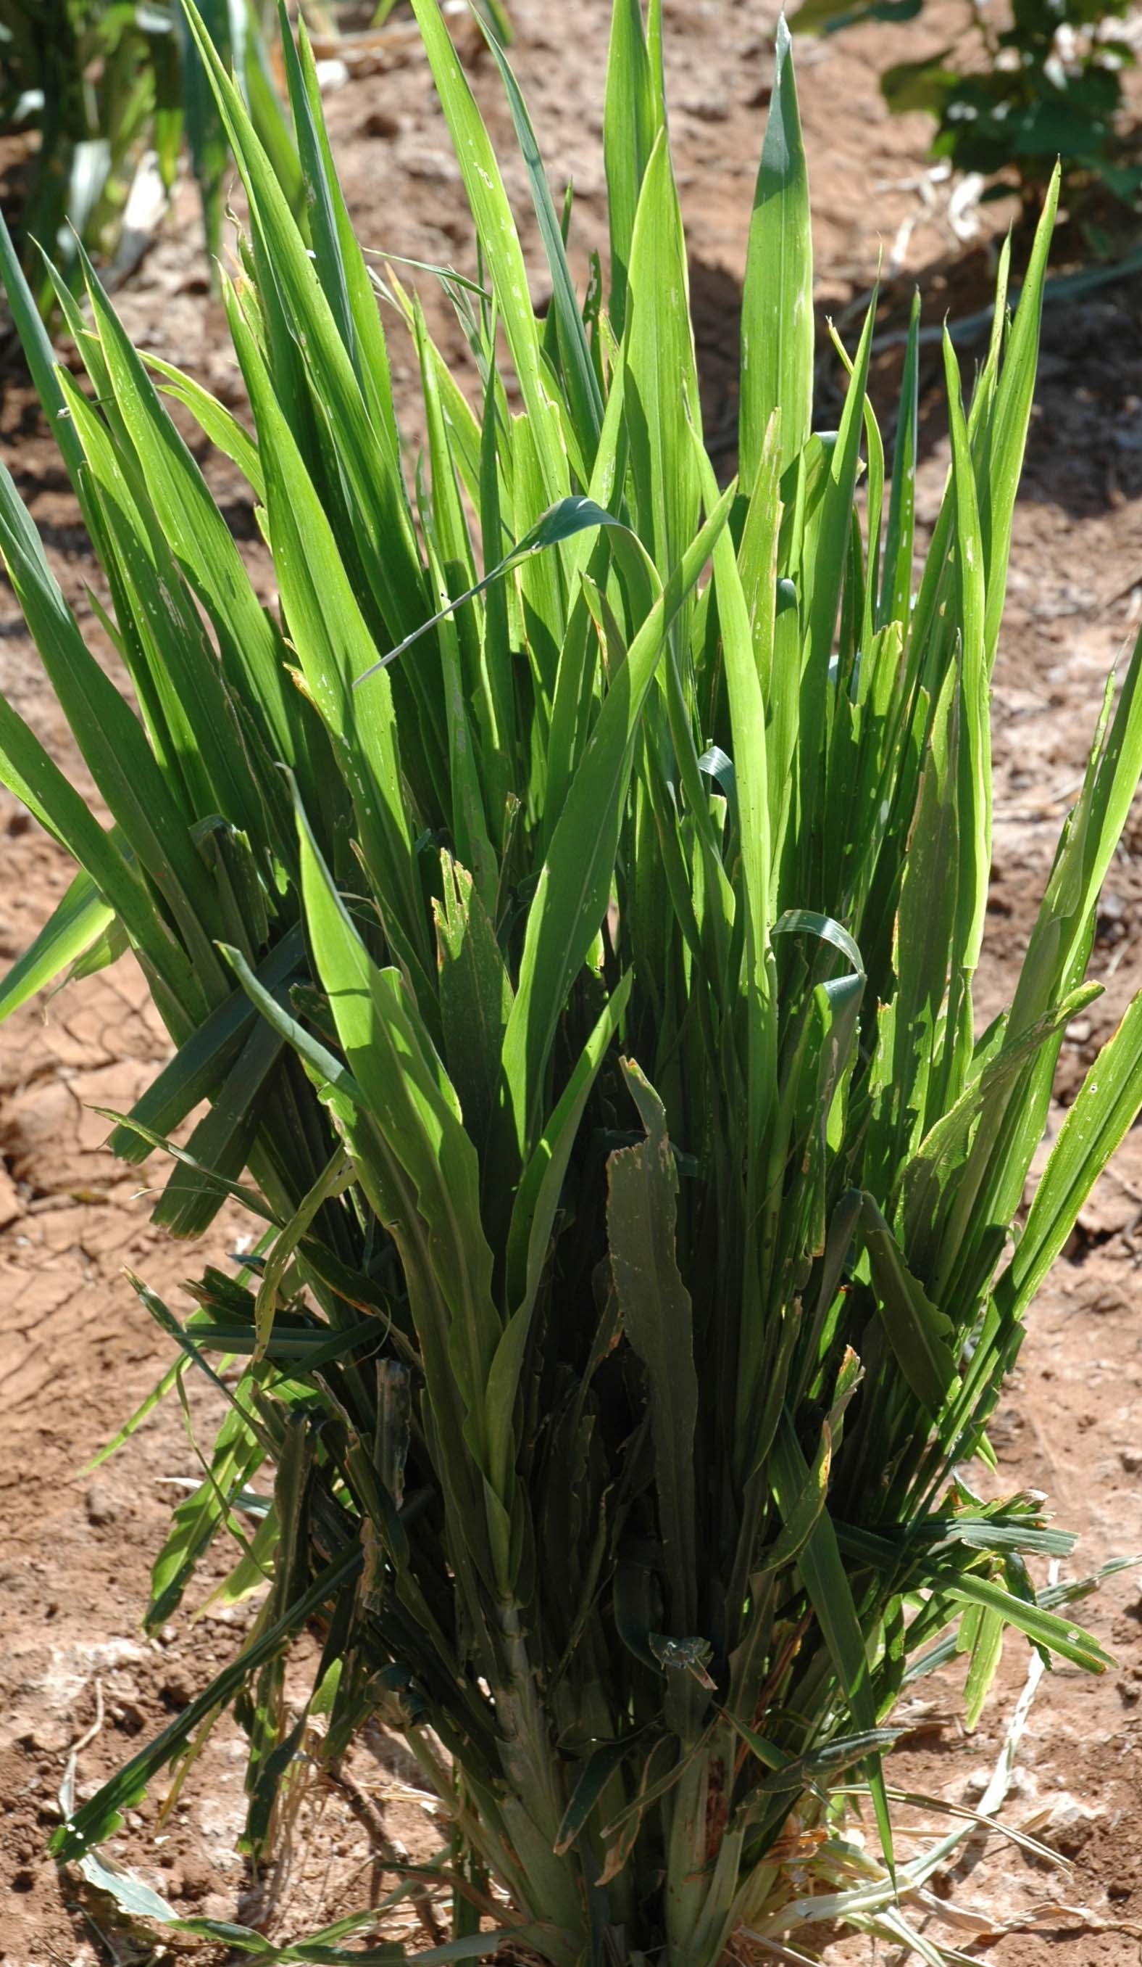
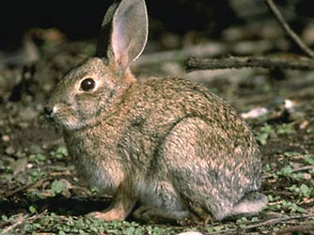
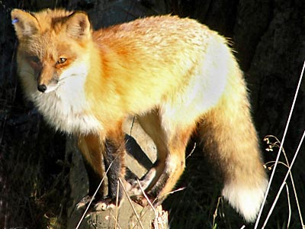

Plants: | _______ |  | Rabbits: | ________ |  | Fox: | 100__
About how many plants and rabbits do you think you would need to support a large fox population (around 100 foxes)? Try predicting and explaining the number of rabbits and plants you need. Write your numbers above, and explain your reasoning in the space below.

Prediction #2. In this investigation you will try to create an ecosystem that has the most biomass after 50 years, in grass, rabbits, and foxes combined. Try predicting and explaining the numbers of plants, rabbits, and foxes that might to into an ecosystem with the most total biomass.

Prediction #3. In this investigation you will watch as the size of the fox, rabbit, and grass populations change over time. Try predicting and explaining the numbers of plants, rabbits, and foxes that might lead to the largest amount of CO₂ and the most O₂ in the atmosphere.

